Tutorial 9.1 Switch Security Configuration

Question 4 (Continued)

- The ABC network topology is shown in Figure 4-2. Provide answers to the questions below:
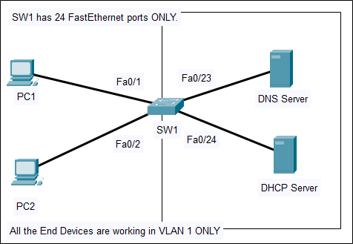
Figure 4-2: ABC Network Topology

(i) Explain DHCP Snooping. (2 marks)

- DHCP Snooping filters DHCP messages and rate-limits DHCP traffic on untrusted ports, preventing DHCP spoofing attacks.
- Devices under administrative control are trusted sources such as switches, routers and servers.
- Devices outside the network and all access ports are generally treated as untrusted sources.

Tutor answer:
- Mitigate DHCP spoofing attack
- Filter DHCP messages and limit DHCP traffic on untrusted port
- Untrusted ports: Fa0/1 and Fa0/2
- Trusted ports: Fa0/23 and Fa0/24

(ii) Provide DHCP Snooping configuration according to Figure 4-2 with a rate limit of 6.
(3 marks)

ip dhcp snooping

interface range f0/23-24
ip dhcp snooping trust
exit

interface range f0/1-2
ip dhcp snooping limit rate 6
exit

ip dhcp snooping vlan 1
end

